It's Holiday Season!
PNGC has a beautiful ballroom, or intimate private dining area, with fantastic cuisine. We have a variety of options that can be personalized to accommodate your budget and taste!
Here are just a few things that we offer at Pittsburgh National that can make your holiday party stand out from the rest!

Ballroom
• Temerature controlled indoor ballroom
• Banquet sit down, or buffet for 180 guests
• Professional wait staff / in-room bar and bar staff
• Complete set up and cleanup service
• Optional move-able dance floor
• Optional decoration service *
•Free Wi-Fi

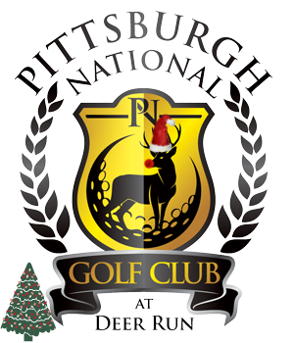

Please contact us
Pittsburgh National Golf Club
To plan your special event!
To set up a tour of our ballroom, or private dining area give us a call. (724) 265-4800

Private Dining
• Free Wi-Fi
•Banquet sit down, or buffet for up to 48 guests
• Temperature controlled
• Professional wait staff / bar and bar staff
• Complete set up and cleanup service
• Optional decoration service *
•Patio access

