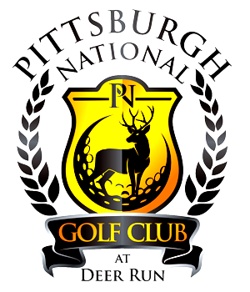

Golf Outings
With
Pittsburgh National Golf Club

Deciding where to host your golf outing can be a big decision. Let us make it easy on you!
Here at Pittsburgh National Golf Club we have a staff, dedicated to making your event a success with ease.
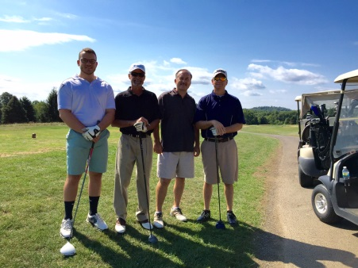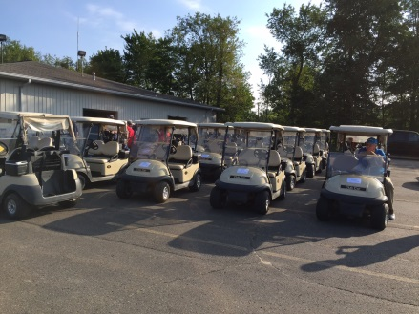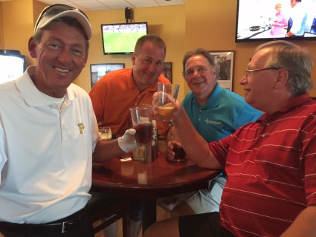
Outing Packages
PNGC offers outing packages to suit different needs. We offer tee time events and shotgun events on weekdays, weekends, and holidays. Tee time Events include 18 holes of championship golf with cart, professional golf outing services, and a $10/player credit in the pro shop. Shotgun Events are available for any size groups. All shotgun events include 18 holes of championship golf with cart, professional golf outing services, and $10/player credit at the pro shop.
Smaller outings are always welcome too. If you have a group of 12 or more, we have the options available to make your day on the course with your smaller outing stand out above the rest.
Outing Banquet
Along with any of our outing packages, we offer our banquet hall with food and beverage packages. Our professional chefs’ staff will set up a menu to match your tastes and pricing needs. We have a variety of breakfast packages including an optional omelet station. Boxed lunches at the turn can also be a great addition to a golfer’s outing experience.
We have themed, executive, and casual sit down meals. Or a buffet dining option, including varying beverage, appetizer, soup, and hor d’oeuvre options that are sure to make your outing stand out from any other.
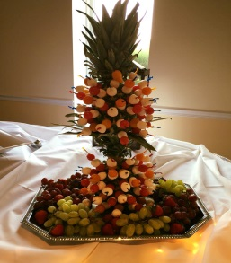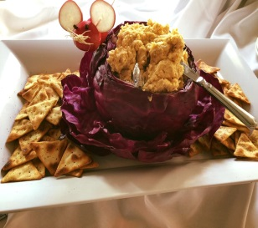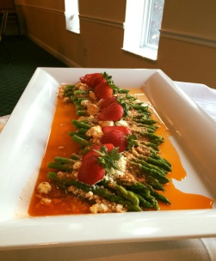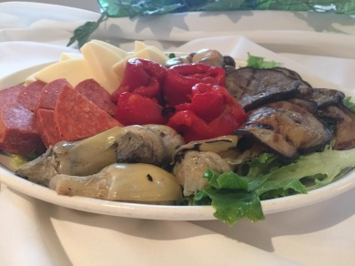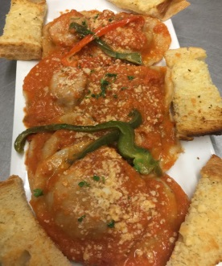
Please contact Pittsburgh National Golf Club to create your specialized event!
287 Monier Rd Gibsonia, PA 15044 (724) 265-4800

