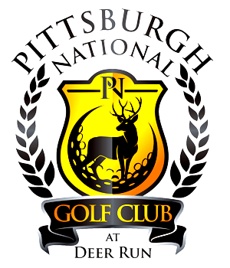

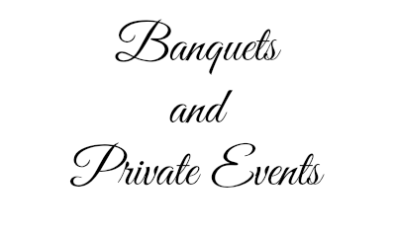

With
Pittsburgh National Golf Club
Have your gathering stand out from the rest, in our beautiful banquet facility!
Business MeetingsReceptions Banquets Holiday PartiesSpecial Events
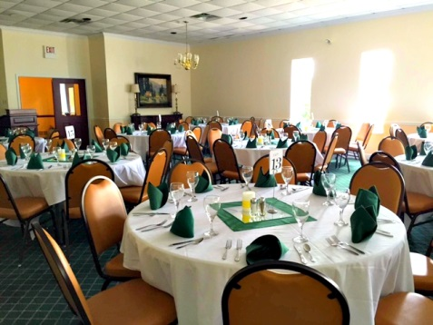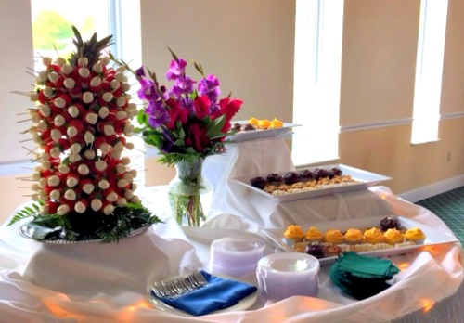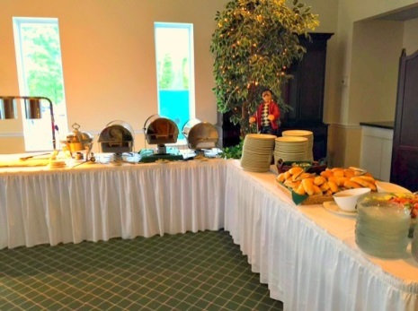
At Pittsburgh National Golf Club, we are always happy to plan and execute parties for our party hosts and their guests! PNGC has staffed professional chefs that have a vast catalogue of different menu options. All menus can be tailored and personalized for budget and can accommodate a variety of tastes!
Here are just some of the great things we offer –
- Air conditioned indoor Ballroom for banquet, sit down, or buffet up to 180 guests
- Conference Room for business meetings, special events, etc. for up to 48 people.
Free Wi-Fi provided. Coming soon-Audio/Visual System
- Professional wait staff / in-room bar and bar staff
- Complete set up and cleanup service
- Optional moveable dance floor
- Optional decoration service *
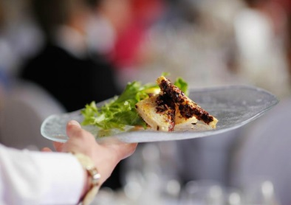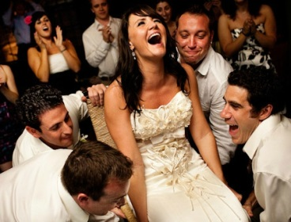
Please contact Pittsburgh National Golf Club to create your specialized event!
287 Monier Rd Gibsonia, PA 15044 (724) 265-4800

